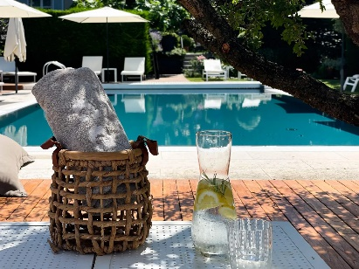 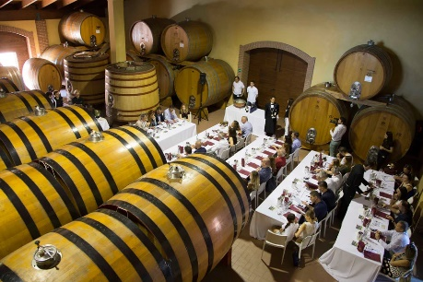

**The Ultimate Food & Wine Adventure to Northern Italy**

**Starring Amarone & Barolo - October 20 to 26, 2025**

**Featuring**

* Visits to the great wineries and wine regions of Verona, Soave, Piedmont
* Top Notch boutique hotel accommodations in Verona and Piedmont
* World-class restaurants
* Amazing wines!
* A visit to the Alba Truffle Festival
* A guided Truffle hunting experience
* Participation in a cooking class with white Truffles, guided by a noted Northern Italian Chef

**Introduction**

Northern Italy offers stunning vistas and wines of great distinction. Take an unforgettable road trip through the vineyards of Amarone and Barolo with VINfluence, (run by Peggy Perry and her husband Brien) and Glenn Fawcett of Vinequest. This will be a 7-day, 6-night experience. Ground transportation, meals featuring the world class wines of the region, accommodations, tours, wine tastings, a guided truffle hunt and a cooking class with white truffles.

Several of our meals will be in Michelin-stared or Michelin recommended restaurants. Our accommodations include:

* 3 nights at our favourite Verona Hotel, the [*Giulietta e Romeo*](https://www.giuliettaeromeo.it/en/) in the heart of the city.
* 3 nights at the [***Corte Gordina Hotel***](https://www.cortegondina.it/)  in the village of La Morra in Piedmont

**Itinerary**

*Please note that the following itinerary is subject to change. Although we have provided specific details regarding the wineries visited, meal locations and the general flow of the trip, please note that there may be changes. 'We always like to make allowance for minor changes and additions to adapt to unforeseen events and capitalize on emerging opportunities!*

We will meet in Verona on Monday, October 20, 2025 at our favourite Verona Hotel, the Giulietta e Romeo which we love for its’ friendly staff and great location in the heart of Verona

That evening, we visit with the [Speri family](https://www.speri.com/en/family/) and learn all about their organic farming philosophy and taste through their wonderful wines. Afterwards we will enjoy a delicious dinner with the Speri wines at a nearby restaurant.

On Tuesday morning we check out Soave. This hillside village gives it name to one of Italy’s’ best known whites. We will enjoy a visit at [Pieropan Winery](https://www.pieropan.it/en), a stunningly beautiful winery making the region’s best white wines. Afterwards the Farina Winery will host us for a tasting and light lunch. This family-owned winery just received the Great Wine Capitals International Award 2024 for the Best of Wine Tourism.

Wednesday we continue with visits in the area, wineries to be confirmed in 2025. In the evening we will enjoy a city tour followed by dinner at one of the many Michelin restaurants in Verona.

Thursday morning, we have an early departure and a full day as we head to the Piedmont, enjoying stunning vistas during the 3-hour drive to the town of La Morra. We have a stop along the way in [Franciacorta](https://www.forbes.com/sites/liviahengel/2019/04/04/a-weekend-guide-to-franciacorta-italys-best-sparkling-wine-region/?sh=70587b9c7cfc) where we will learn about Italy’s most prestigious sparkling wine and enjoyed a bubble-based lunch. Upon arriving in La Morra, we will settle in at the ***[Corte Gordina Hotel](C:\\Users\\glenn\\Documents\\aaa-Northern Italy\\Corte Gordina Hotel)*** for 3 nights. This beautiful hotel in the village of La Morra will be the perfect starting point for our daily excursions.

Friday is a full day of winery visits starting right in La Morra at [Enzo Boglietti](https://enzoboglietti.com/company/?lang=en). It is a short walk from our hotel. This very small family run winery is making wonderful wines, and we will taste through their entire line up.

Late afternoon finds us at [Viberti winery](https://www.viberti-barolo.com/en/) where we will enjoy a visit with Claudio Viberti and have dinner at [***Buon Padre Restaurant***](https://www.buon-padre.com/ristorante_en.php) which his family has owned for years. This is where Brien and Peggy had the best meal of our lives in 1986 and it has never been surpassed!

Saturday morning, we are off on a truffle hunt to find some white truffles of our own. We will not know our destination until the last minute as truffle hunters guard their hunting spots very carefully. In the afternoon

are off to the [***Alba Truffle Festival***](https://www.fieradeltartufo.org/en/) to try a few glasses of wine and enjoy visiting the truffle booths and watching the interaction between sellers and buyers of the famous Alba white truffle. We will take part in a cooking class and enjoy the pasta we produce with more white truffles!

On Sunday, it is time to check out. At the end of the tour, October 26, 2025, the drop off point is the Alba train station or the Milan Malpensa airport. Please reach out to Peggy at [peggy@vinfluence.net](mailto:peggy@vinfluence.net) if you have any questions.

**Summary**

This will be an all-inclusive 7-day, 6-night experience. Ground transportation, all meals including several featuring the world class wines of the region, accommodations, tours, wine tastings, a guided truffle hunt and a cooking class with white truffles featured is all covered in the cost of the tour which is $5700 plus GST based on double occupancy. This trip also includes transfers to the airport or train stations at the beginning and end our tour. Single supplement is available up request

The tour does not cover personal travel insurance, airfare to and from Italy,

We request that you meet us at Hotel Giulietta e Romeo, Verona on Tuesday, October 20, 2025 by 16:00h. At the end of the tour, October 26, 2025, the drop off point is the Alba train station or the Milan Malpensa airport. Please reach out to Peggy at [peggy@vinfluence.net](mailto:peggy@vinfluence.net) if you have any questions.

**To reserve your participation on the Ultimate Food & Wine Adventure to Northern Italy**

Please notify Glenn Fawcett as soon as possible so that he can hold space for you. Hurry though! There is room for only 14 lucky people on this adventure. A 50% deposit is required by Oct. 20, 2024, and the balance is payable on April 20, 2025.

**Further information**

Please reach out to Glenn Fawcett at [Glennfawcett5@gmail.com](mailto:Glennfawcett5@gmail.com) if have any questions.